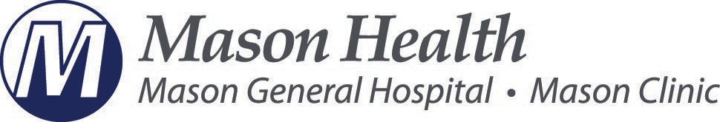

**PUBLIC HOSPITAL DISTRICT #1**

**Special Board Meeting Agenda**

**May 13, 2024**

12:30 p.m. Call to Order in person at Alderbrook Resort 10 E Alderbrook Dr. Union, WA 98592

**ROLES**

### Leader………………Gayle Weston, President

###### Recorder……………Shelly Dunnington

**12:30 p.m. – 4:00 p.m.**

12:30 p.m. – Working Lunch - 2025 Strategic Process Discussion

1:30 p.m. - Upcoming Conferences

2:00 p.m. - Succession Planning

3:00 p.m. - Executive Session - Performance of a Public Employees RCW 42.30.110(1)(g).

(Possible Action to be Taken) in regular meeting.